Mayor of Suwon City
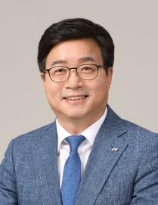
□ Personal Information
○ Name : YEOM Tae-young
○ Date of Birth : July 25, 1960
○ Education & Qualification
- B.S. in Agricultural Chemistry, Seoul National University
- Professional Environmental Engineer
○ Marital Status : Married with one son
□ Key Careers
○ Incumbent Posts
- 5th~7th Popularly Elected Mayor, Suwon City, Republic of Korea
(Jul. 2010 ~)
- Supreme Council Member, Democratic Party of Korea (Aug. 2020 ~)
- Chair, National Association of Mayors of Korea (Jul. 2019 ~)
- Member, OECD Champion Mayors (Oct. 2017 ~)
- Member, Global Executive Committee, ICLEI – Local Governments for Sustainability (Sep. 2010 ~)
- Member, Executive Committee, CityNet(local governments’ association in the Asia Pacific Region) (Jan. 2018 ~)
- Cochair, National Action for Constitutional Amendment on Decentralization (Oct. 2012 ~)
- President, World Toilet Association (Nov. 2013 ~)
- Member, Presidential Committee on Balanced National Development (Jul 2019 ~)
- Cochair, Forum ‘Self-governance and Balance’(Jun. 2020 ~)
- Standing Chair, Korea Democratic Leadership Council for Autonomy Decentralization(KDLC) (Jun. 2020 ~)
○ Past Posts
- Employee, Samsung C&T Corporation
- Co-representative and Secretary General, Suwon Environmental Movement Center
- Founding Secretary General(concurrently with Secretary General), Local Substantiality Alliance of Korea
- Secretary to the President of Korea for National Agenda for Roh Moohyun Administration (Jan. 2005 ~ Feb. 2006)
- Standing Auditor, Korea National Park Service
- Member, Presidential Advisory Commission on Policy Planning
(2007 ~ 2008)
- Member, Presidential Committee on Jobs (2017 ~ 2019)
- Vice Spokesperson, Democratic Party of Korea (2010)
- Chair, World Heritage Cities Conference (Nov. 2010 ~ Oct. 2012)
- Chair, National Association of Municipal Mayors, Democratic Party of Korea (Jul. 2017 ~ Jul. 2018)
- Standing Chair, Local Governments Association for Town Creation (Sep. 2015 ~ Oct. 2018)
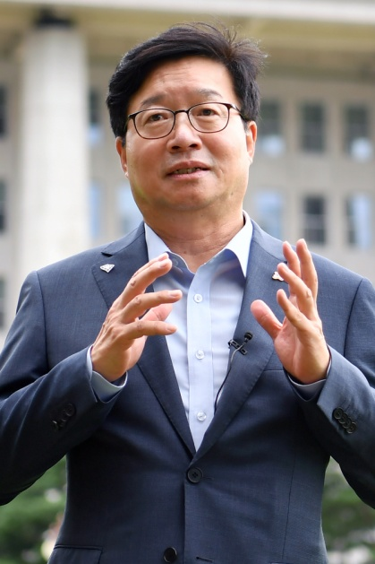 | 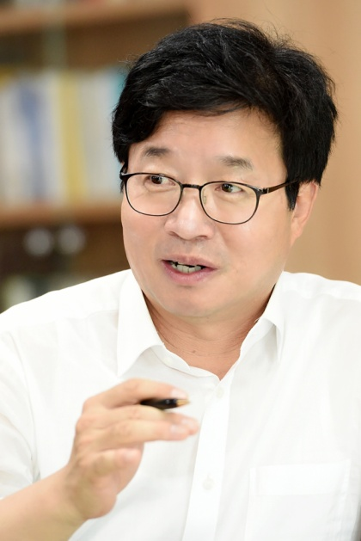 | 